HUG THE RAIL

IOT

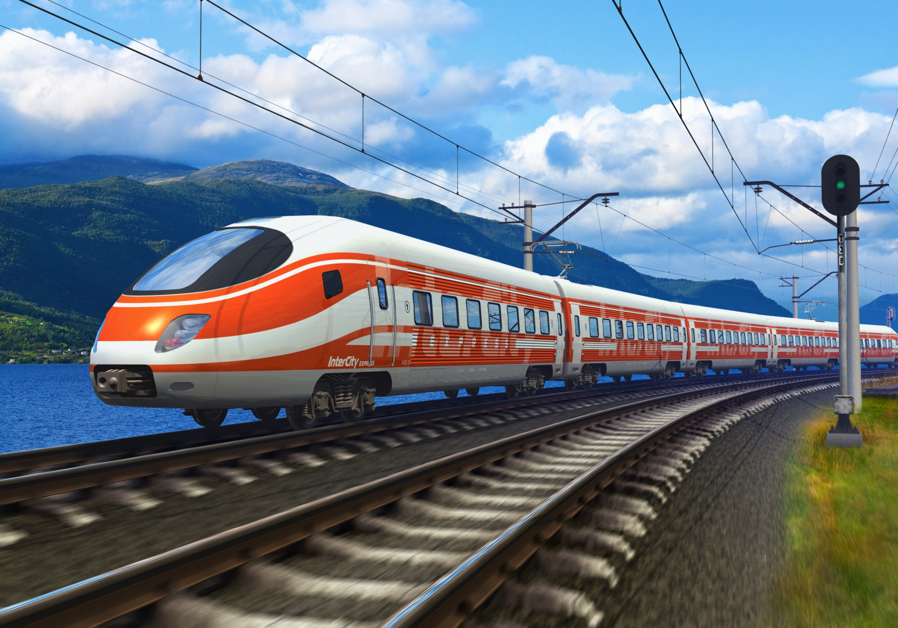

Trent Zeller, Jacob Wood, Steven Hoang, Roland Tumbokon

# Section 1:

### 1.1 Introduction

The internet of things or IoT for short describes a collection of sensors and other technologies that communicate with each other. Currently, trains use cellular networks to transmit their data, such as speed and location. The problem we currently face is the consequences of losing connections with the trains. Thus, we are developing systems in order to keep the trains running smoothly and safely when connection is lost. We are doing this by utilizing all the sensors on the train and directing the information and guidance to the train operators via an interface.

#### Diagram 1.1

### 1.2 Team

Our team consists of four members each with their own roles, but we will be working together closely to complete the project. Our team leader will be Steven. He has a lot of experience with this and is a certified scrum master. He will be in charge of dividing up the work for the team and changing the requirements or tasks depending on how the project is going. Trent will be the coordinator who is in charge of making sure everyone is getting their assigned work done on time and that nobody is falling behind. He will work with Steven if work assignments need to be adjusted or changed. Roland will be in charge of design. He will be working with software such as Adobe Illustrator and Photoshop to create the visuals and designs for the system. He will make the models to show the investors the progress that is being made and show them different possibilities for the future. Jacob will be the lead coder. He will decide the main structure of the system and how it will be split with pseudocode. While he will be in charge of making the overall outline of the code, all the team members will help to make it.

### 1.3 Solution Abstract

We will be using many different types of software for our solution. We have decided to use Java to code the project. This is the language we have the most experience with and feel like we can make the best solution in. We will also be using Trello and Gitlab to keep track of our work and to make sure that we are staying on time.

We will be using a unified process model to complete this project. We decided this would be the best way to make sure that any change in requirements could be completed and it would allow us to review and correct any problems we have. It will also allow us the most interaction with the stakeholders.

### 1.4 Timeline

#### Diagram 1.4

Project Start: February 1st

Communication: February 1st - February 10th

Planning: February 10th - March 1st

Modeling: March 1st - March 10th

Construction: March 10th - March 31st

Deployment: April 1st

# Section 2:

### 2.1 Statement of the problem:

The train operation depends on live data received from the Central Operation Center Servers via WiFi/Cellular network. We need to be able to operate the train when we lose WiFi/Cellular connection. We need to develop a system to allow us to continue the trip safely based on local data that we can collect in real time. This system will also have to be secure and streamline all the information to the train operators.

### 2.2 Required Data:

The IoT system will need to collect data in order to properly advise train operators on safe actions to take. The system will need data on the train’s obstacles and physical surroundings. In particular, it will need to know if there are objects in front or back of the train, especially other trains or moving objects, as well as the status of crossing gates. The IoT system will also keep track of the train’s wheel speed in order to detect when the wheels are slipping. The train will also need to collect GPS data for this purpose, to determine its speed. The system will also need to be aware of inclement weather, so it must detect snow, ice, rain, temperature, and wind speed.

### 2.3 Expected output of IoT:

IoT interfaces with sensors to collect data, analyze the data, use a rule-based logic to issue recommendation or action to the operator via the IoT screen.

If the system detects a hazard on the rails, the IoT screen will make a recommendation (based on speed and distance) that the operator change speed or stop to avoid a collision.

If the system detects the wheels slipping from sensors that detect wheel rpm, the system will recommend the operator slow down and pour sand on the rail. Once the rpm of the wheels have slowed and the slipping stops, the train will inform the operator.

If the system detects inclement weather, the IoT screen will recommend that the operator will slow down until the inclement weather stops.

### 2.4 Sensors:

* Obstacle detection:
  + Railway Optical Detection of Intrusions and Obstructions. This sensor searches for obstacles that are on the tracks.
* Freight Load Sensor:
  + Weight scale for each car means the operator can check for theft
* Rail Friction Sensor
  + Checks the speed of the train using GPS data and the RPM of the wheels. If there is a discrepancy between the information given and can determine if the train is slipping.
* Time of Flight Sensor:
  + Detects the speed of surrounding objects

### 2.5 Conceptual Architecture

The Iot Software receives information and data from the sensors. Once it has this information, it will test to see if there are any problems or information that the operator requires. Any critical or requested information will be sent to the operator’s screen. This will allow the operator to receive any information that will be relevant to his needs without a wifi connection.

